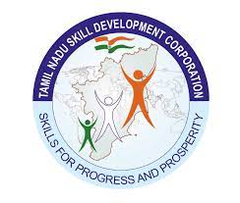



**NAAN**

**MUDHALVAN**

**Project Based Experiential**

**Learning**

UNVEILING MARKET INSIGHTS: ANALYSING SPENDING BEHAVIOUR AND IDENTIFYING OPPORTUNITIES FOR GROWTH

Under the Guidance of

Ms M. Anusiya, M.Sc., M.Phil.,(Ph.D.)

Faculty Mentor, Assistant Professor of Mathematics,

Bon Secours College for Women,

Thanjavur.

**BON SECOURS COLLEGE FOR WOMEN**

NAAC Accredited with A++ Grade in Cycle II

Affiliated to Bharathidasan University, Tiruchirappalli

UGC Recognized by 2(f) and 12(B) Institutions

Villar Bypass, Thanjavur -613 006.



**INDIA’S AGRICULTURAL CROP PRODUCTION ANALYSIS (1997-2021)**

**Submitted by**

Team Leader : Ms A.R.K. Nanthini Kanna

Team Members : Ms P. Pavithra

Ms S. Sandhiya

Ms S. Alin Jerofiya

**PROJECT REPORT**

**1. INTRODUCTION**

**1.1 Overview**

This report delves into the captivating realm of India's agricultural cultivation, providing a comprehensive visual exploration of key aspects and trends in the agricultural sector. Through the visual representations, readers can gain valuable insights into crop production, seasonal variations, regional distribution, and overall production trends. These visualizations enable intuitive analysis, allowing stakeholders to uncover patterns, identify areas of growth or concern, and make data-driven decisions.

By harnessing the power of Tableau, this report not only presents the data in a visually appealing manner but also provides an interactive experience for readers to explore the intricacies of India's agricultural cultivation. To Extract the Insights from the data and put the data in the form of visualizations, Dashboards and Story we employed Tableau tool.

**1.2 Purpose**

The economic contribution of agriculture to India's GDP is steadily declining with the country's broad-based economic growth. Still, agriculture is demographically the broadest economic sector and plays a significant role in the overall socio-economic fabric of India.

**2. PROBLEMS DEFINITION & DESIGN THINKING**

**2.1 Empathy Map**

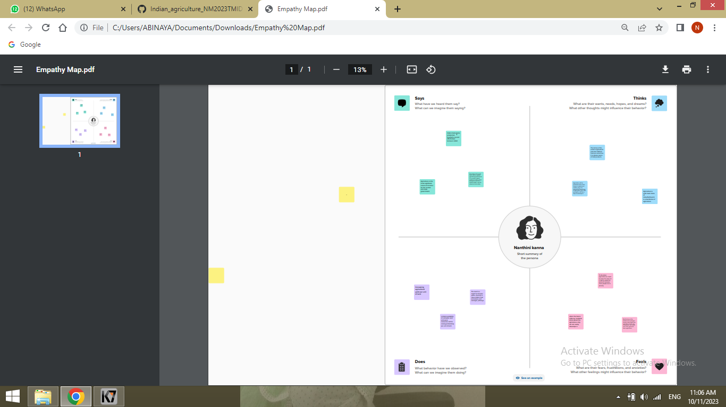

**2.2 Ideation & Brainstorming**

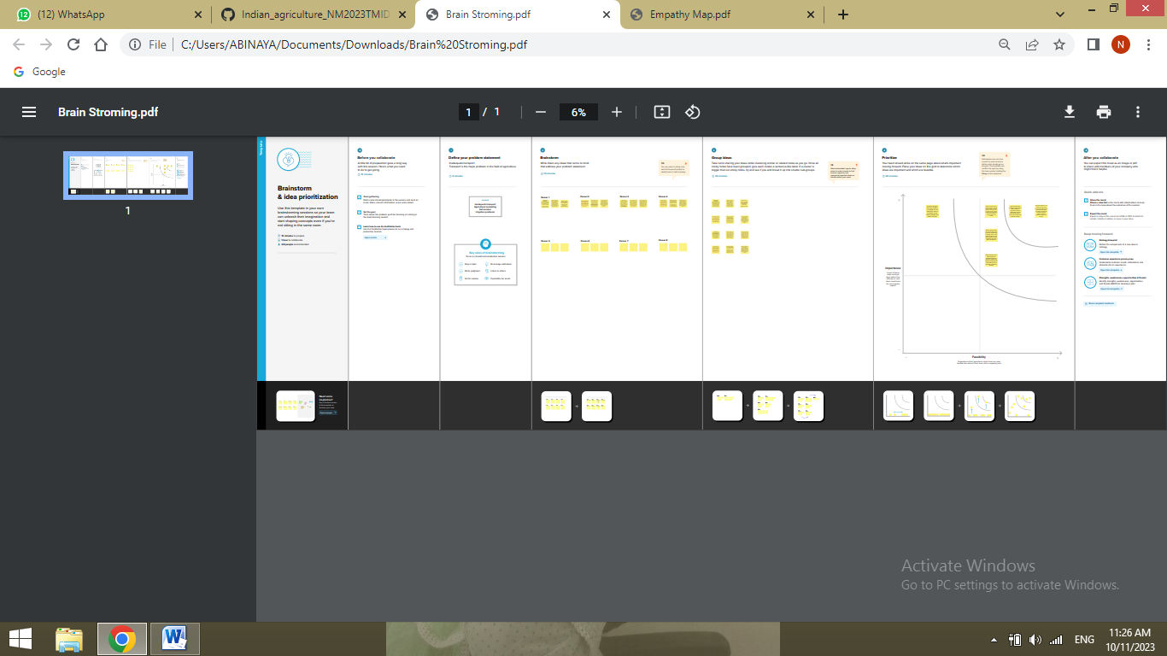

**3. DATASET**

**3.1 Indian Agricultural Crop Production**

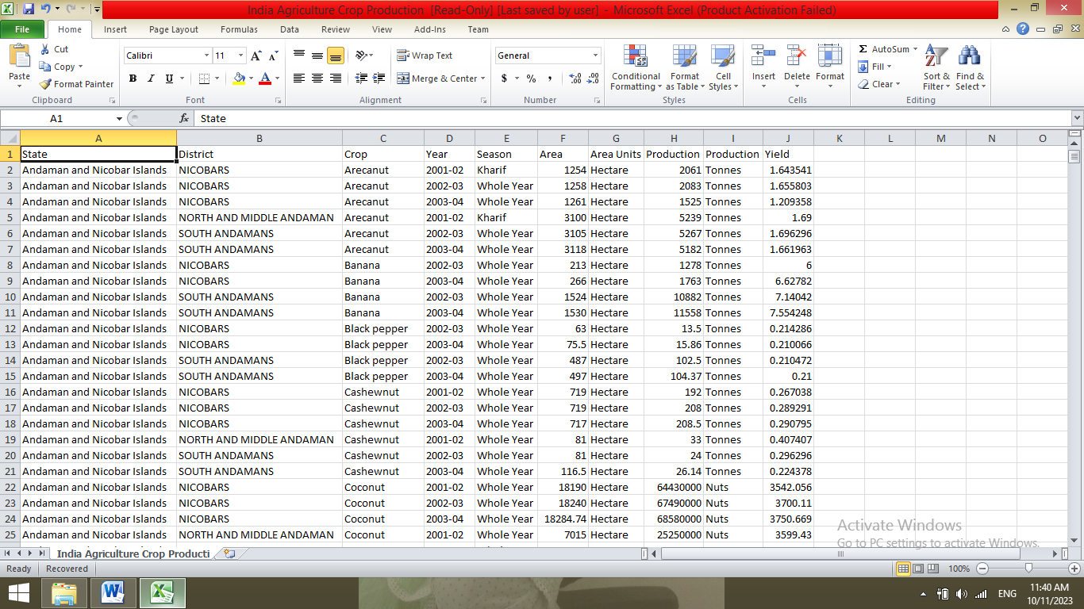

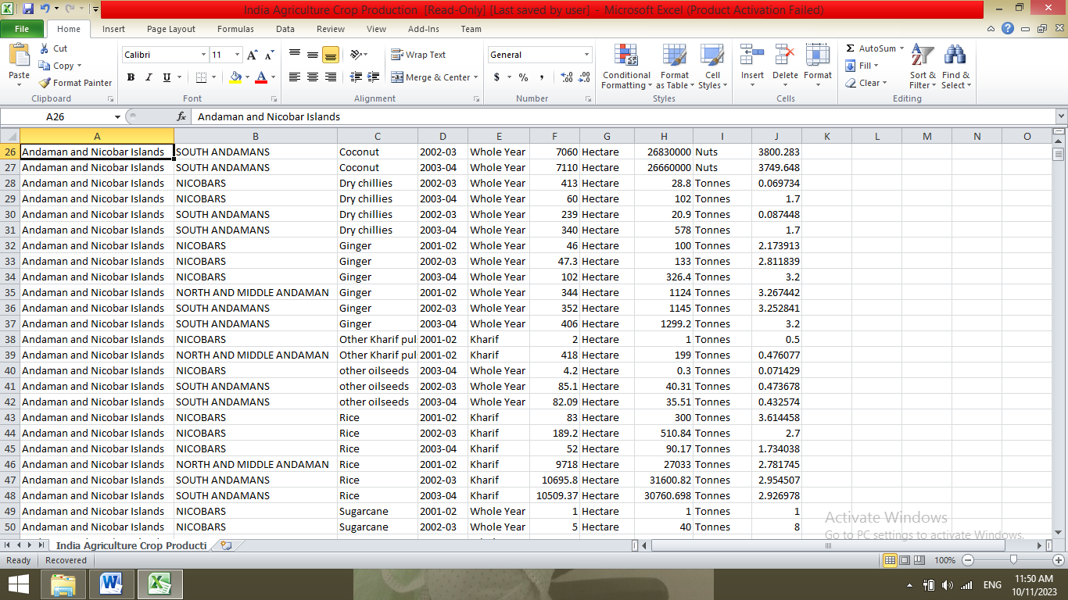

**4. VISUALIZATIONS**

**4.1 State wise Agricultural Land**

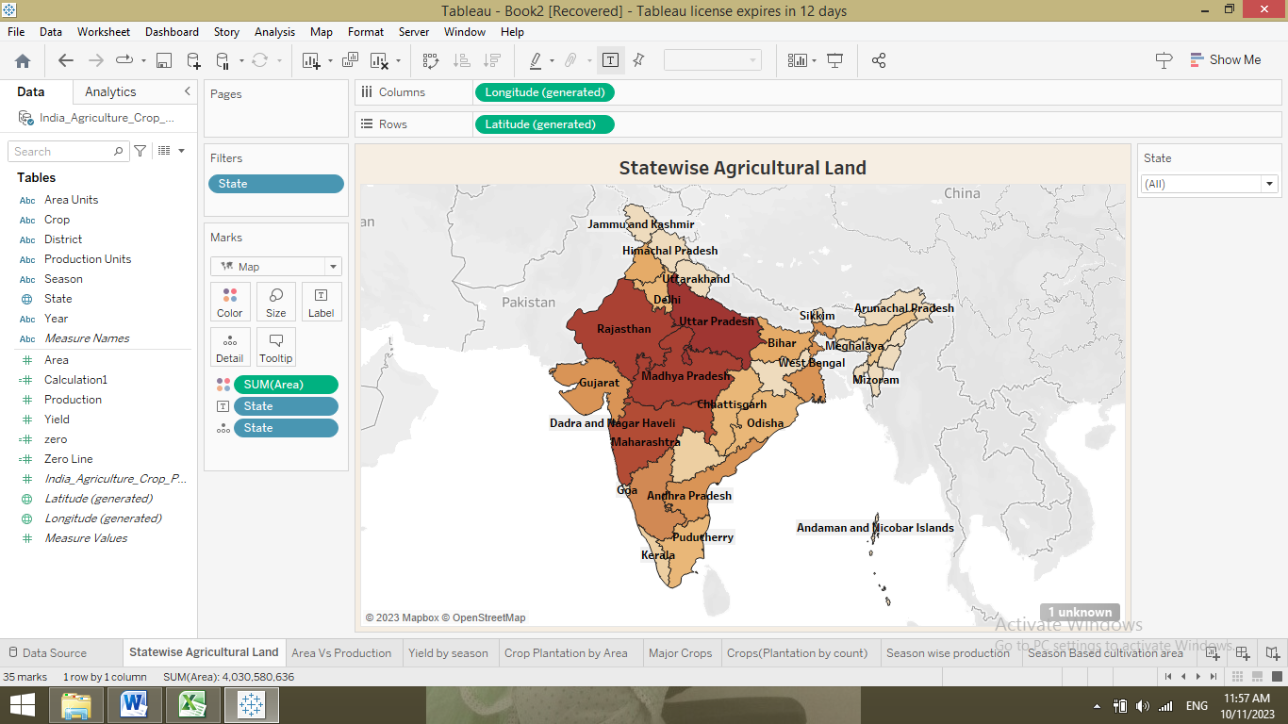

**4.2 Area Vs Production**

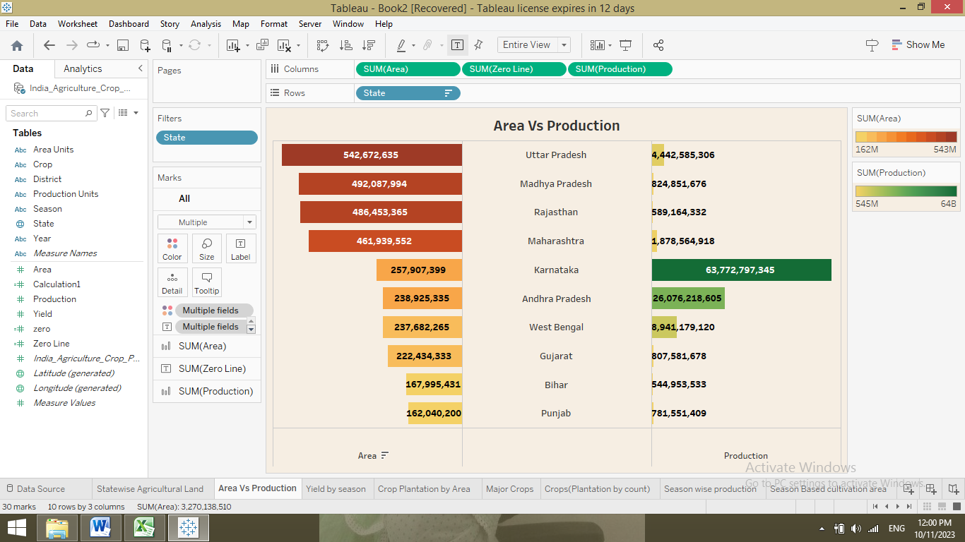

**4.3 Yield by season**

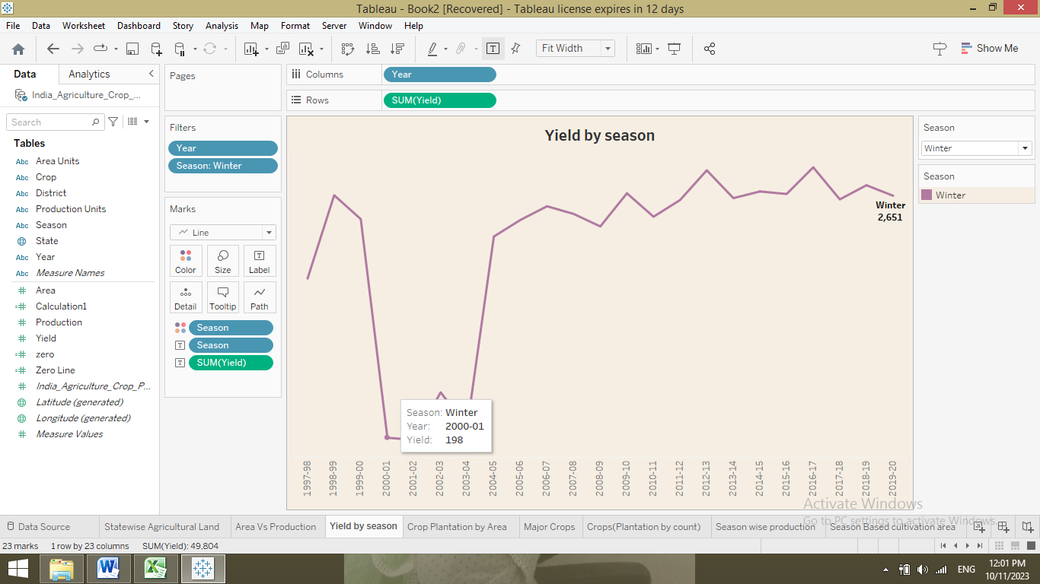

**4.4 Crop Plantation by Area**

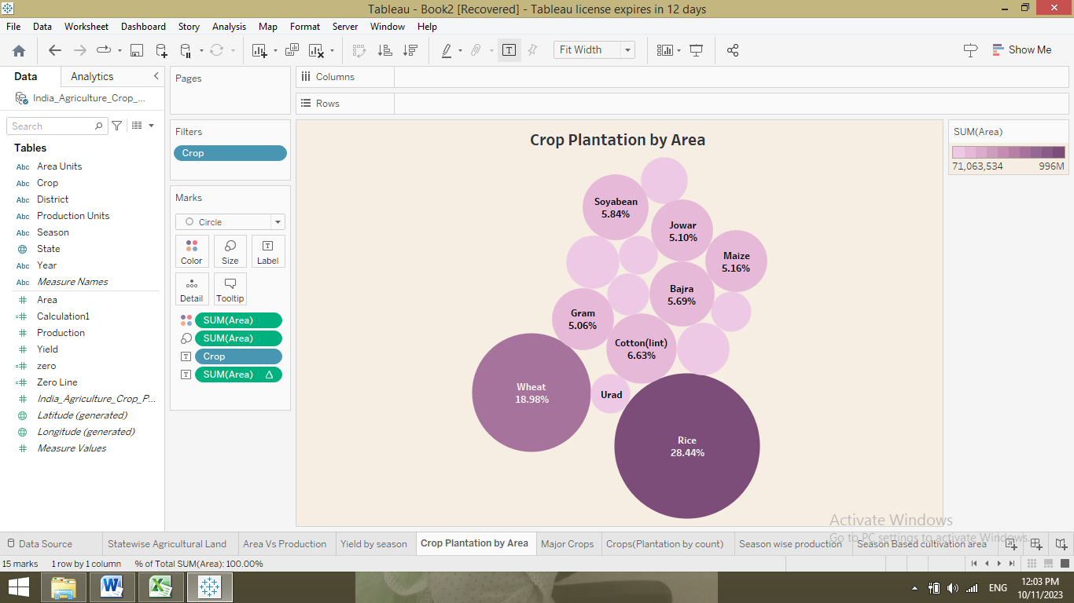

**4.5 Major Crops**

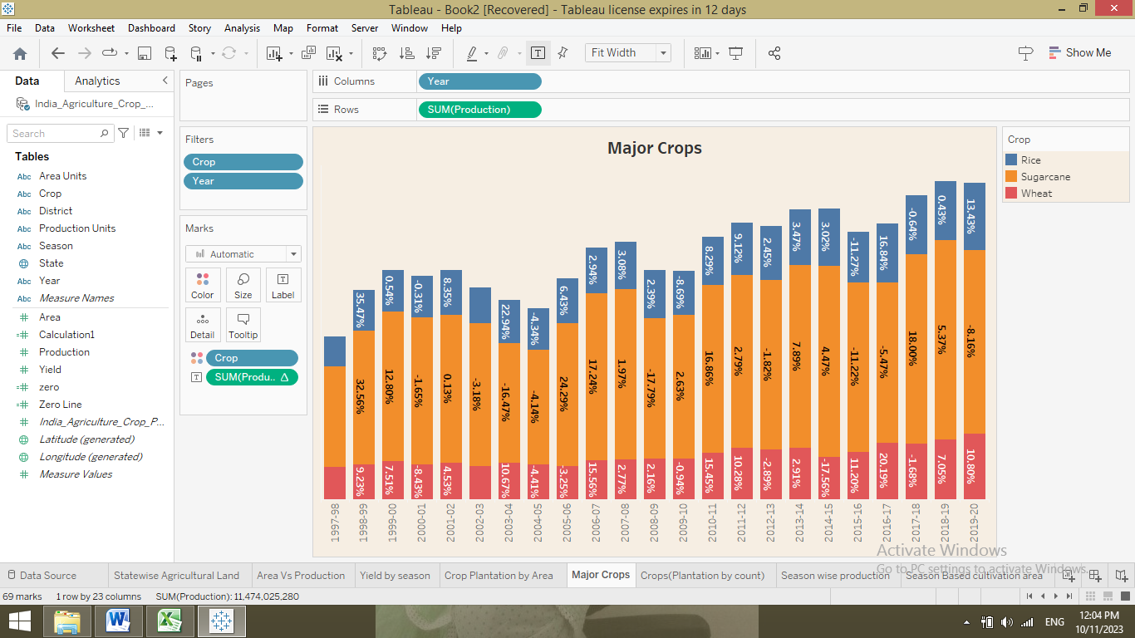

**4.6 Crops (Plantation by count)**

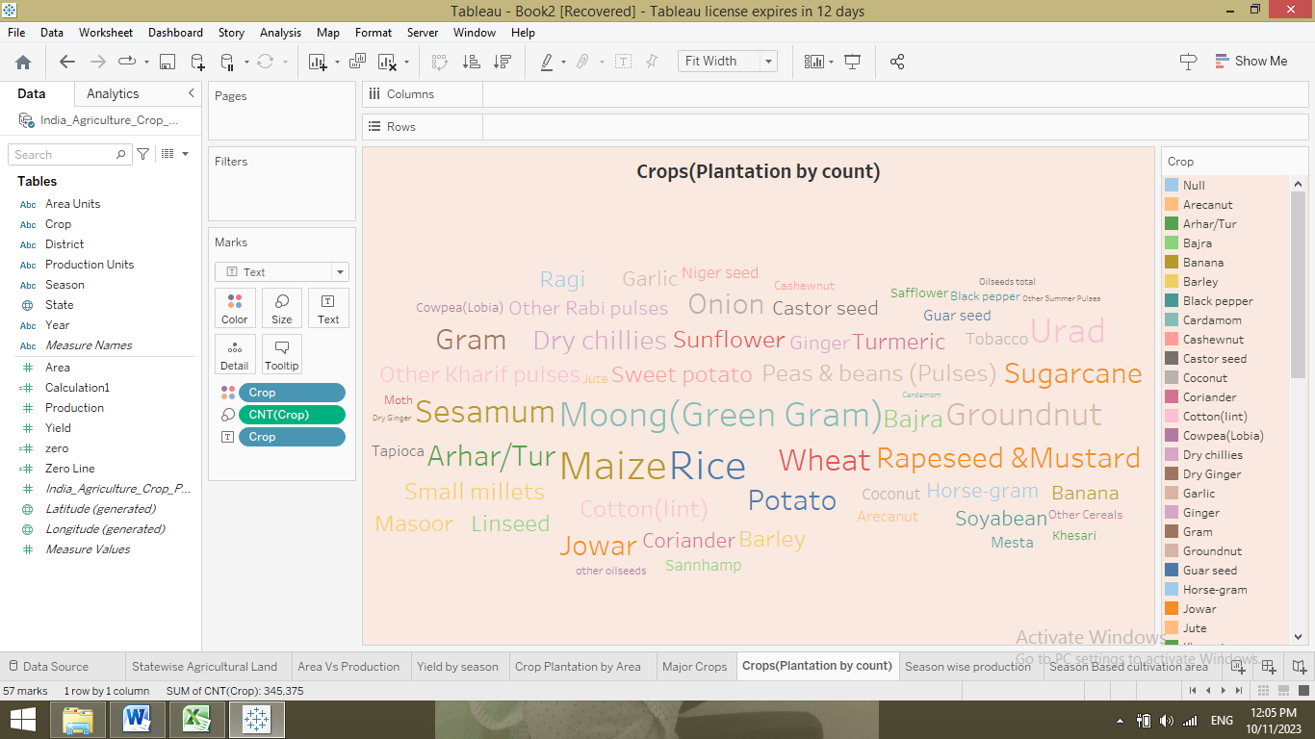

**4.7 Season wise production**

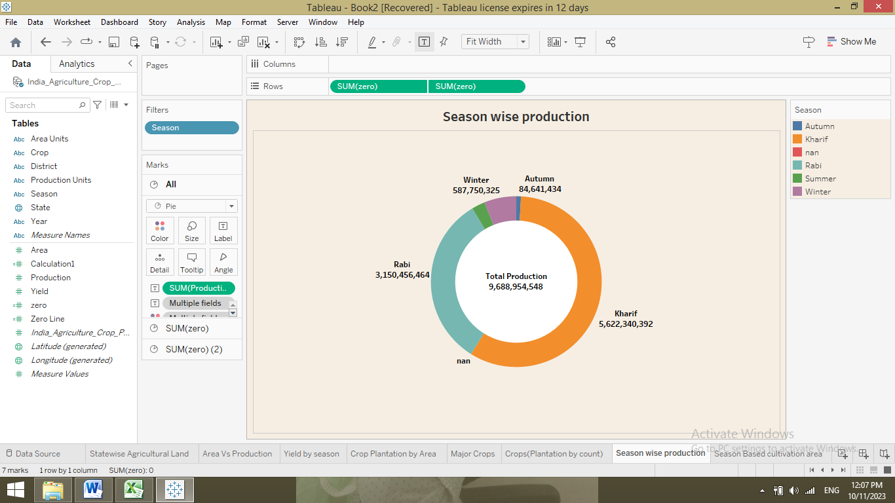

**4.8 Season Based cultivation area**

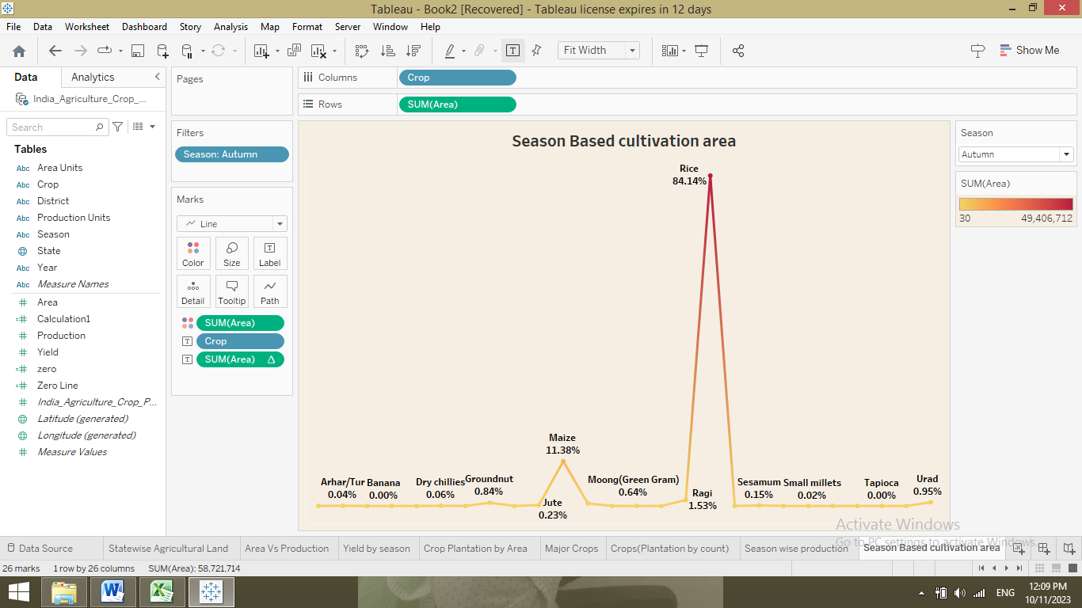**5. RESULT**

**5.1 Dashboard**

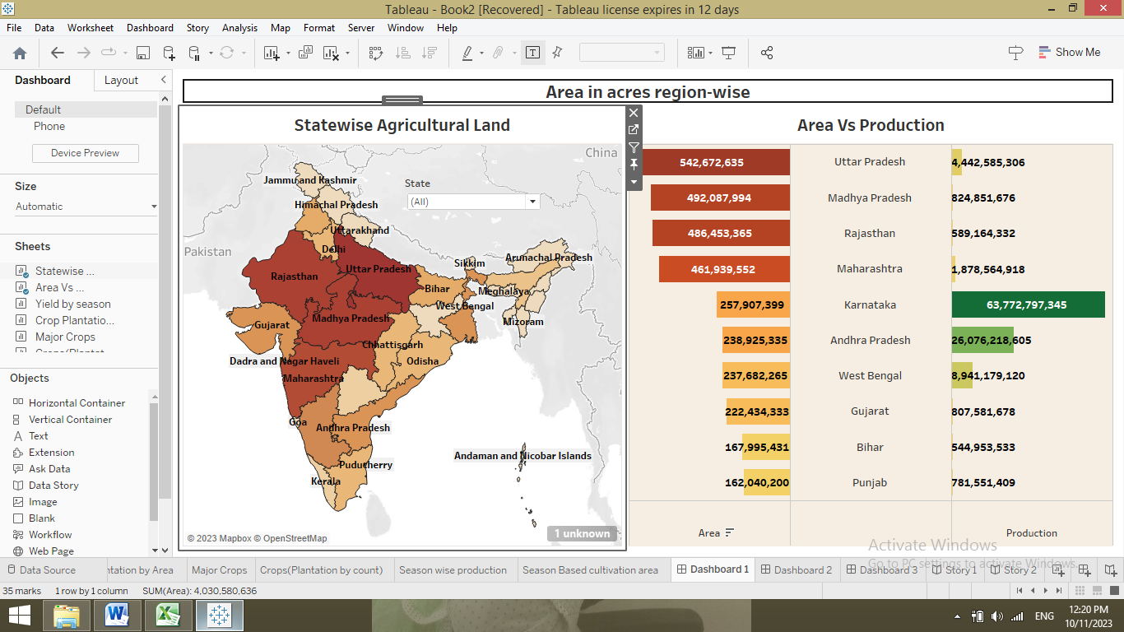

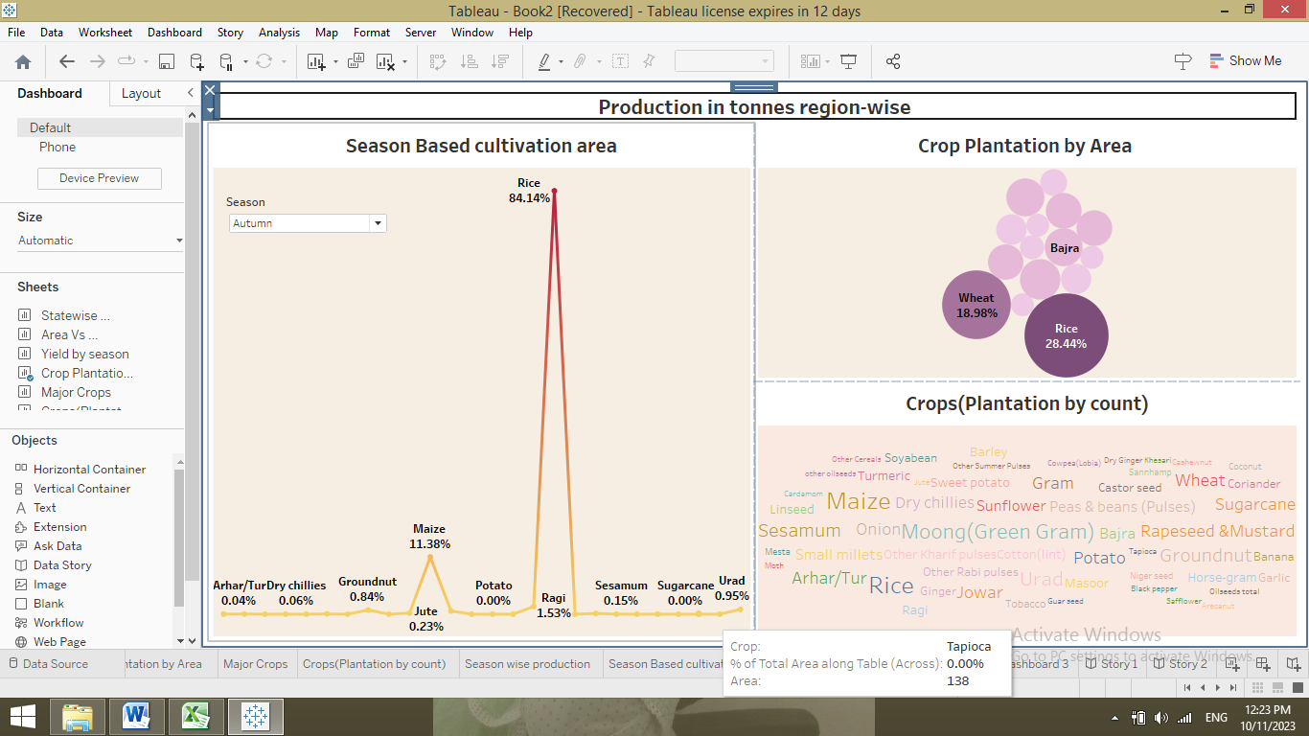

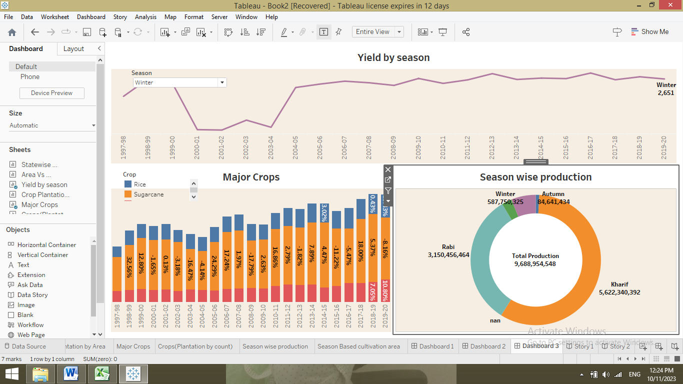

**5.2 Story**

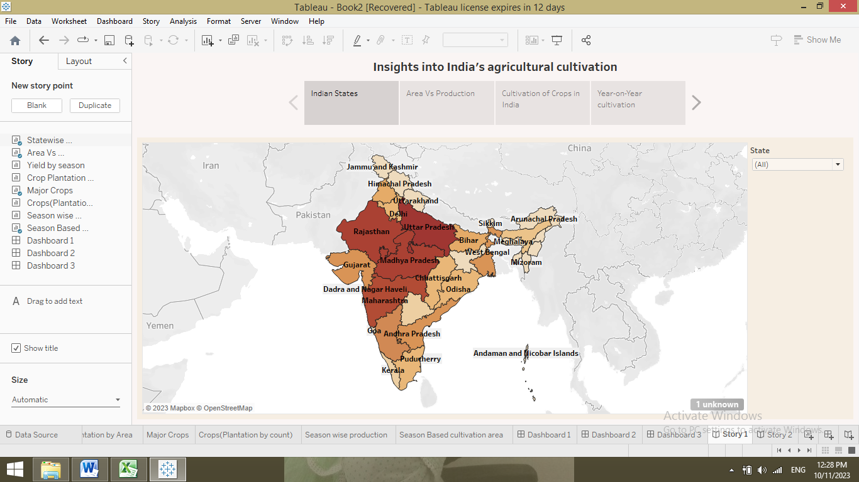

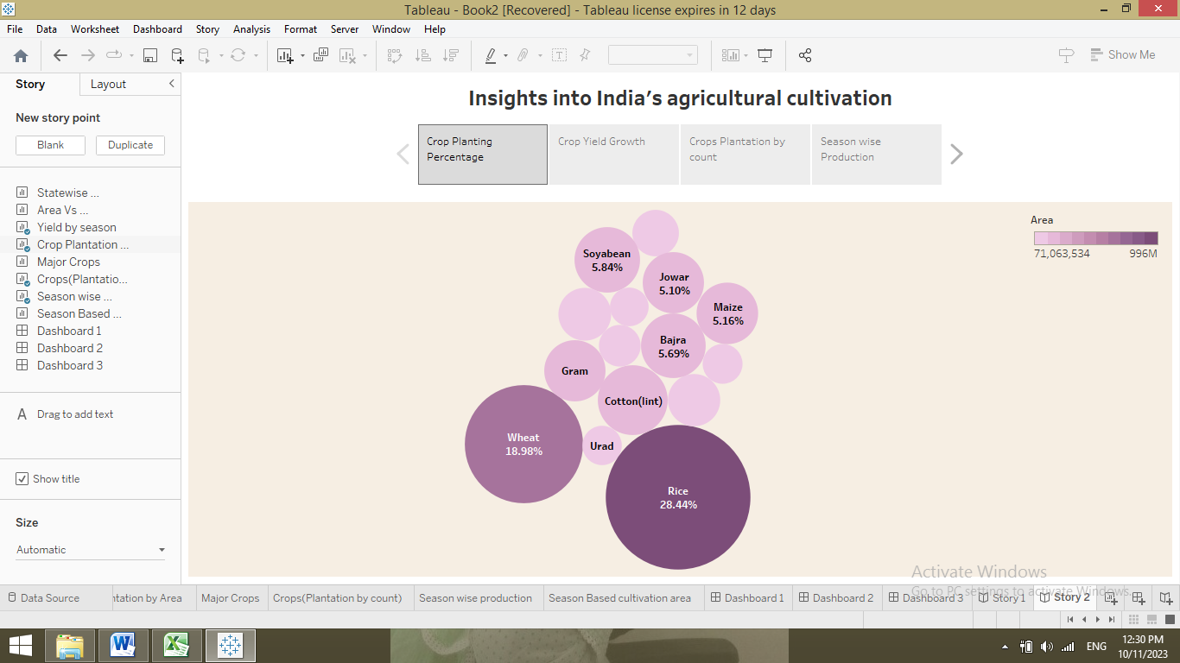

**6. PUBLICATIONS IN TABLEAU PUBLIC**

**6.1 Publication of Dashboard**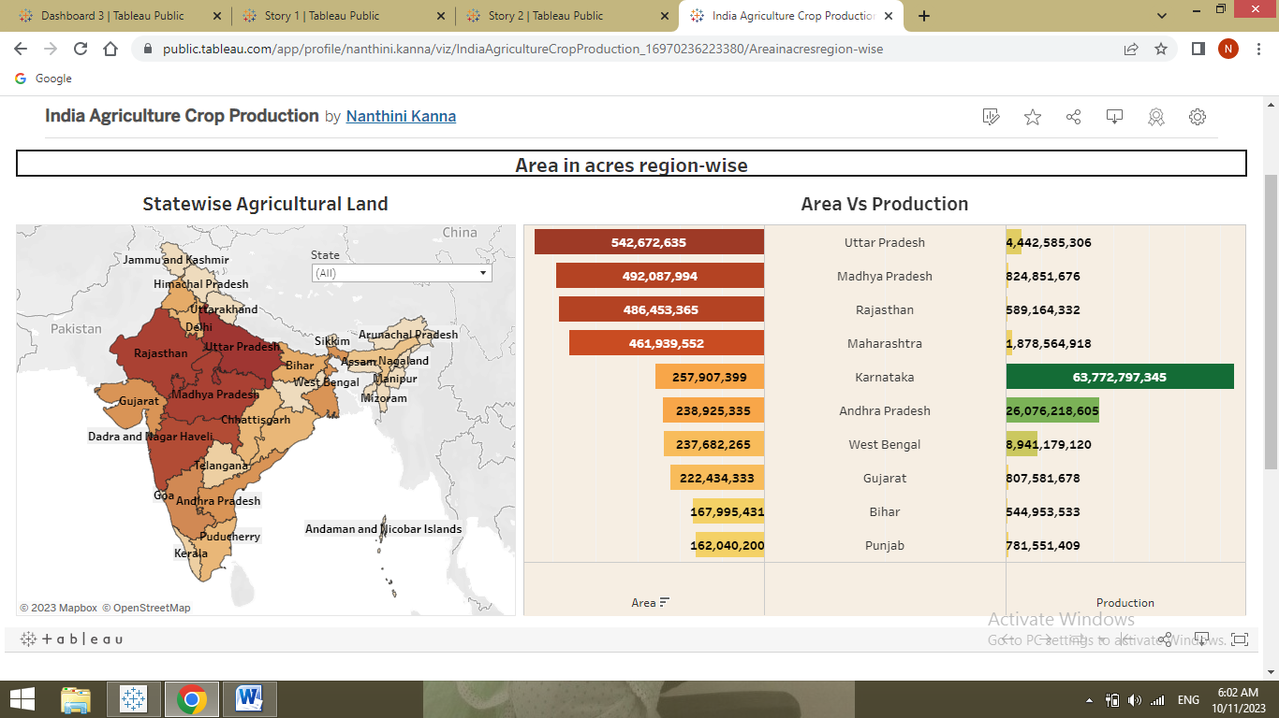

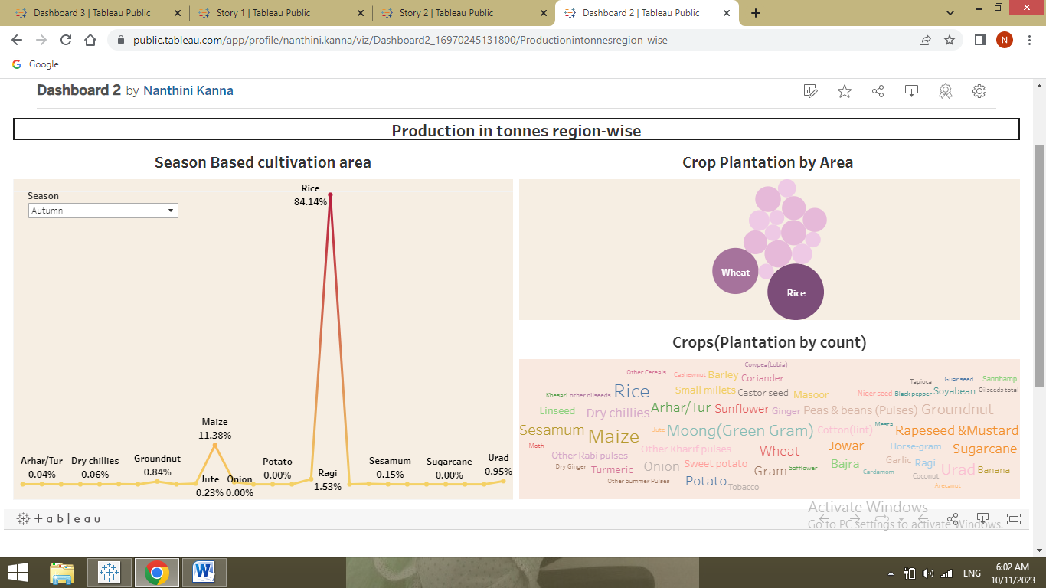

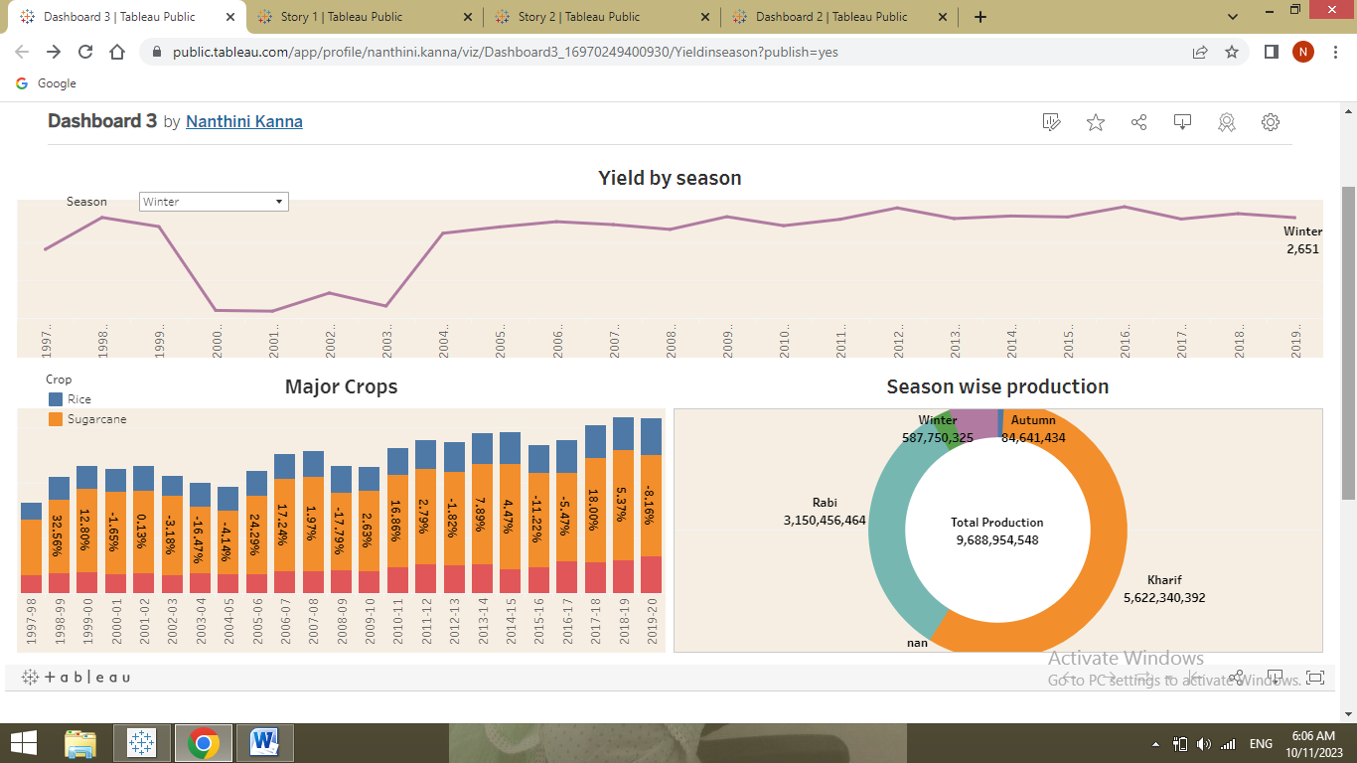

**6.2 Publication of Story**

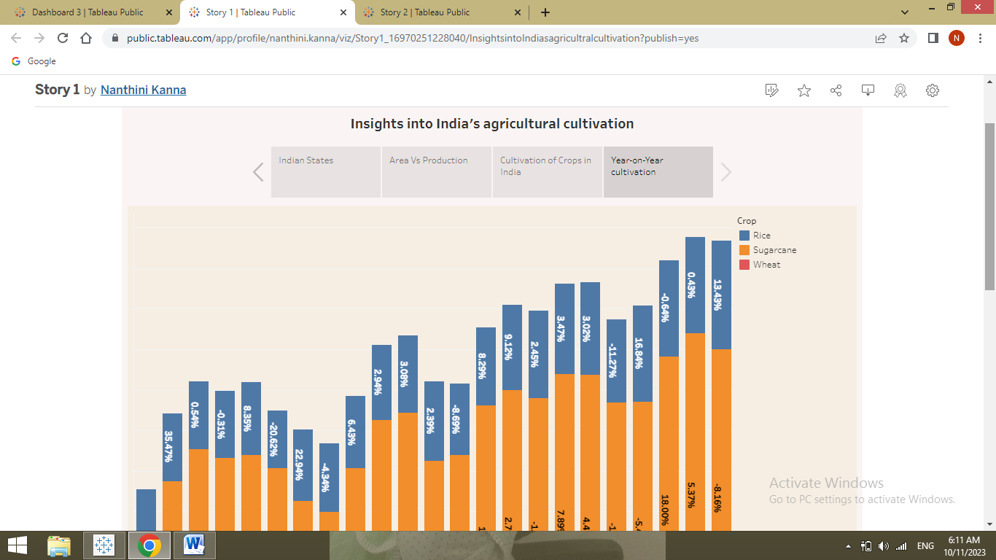

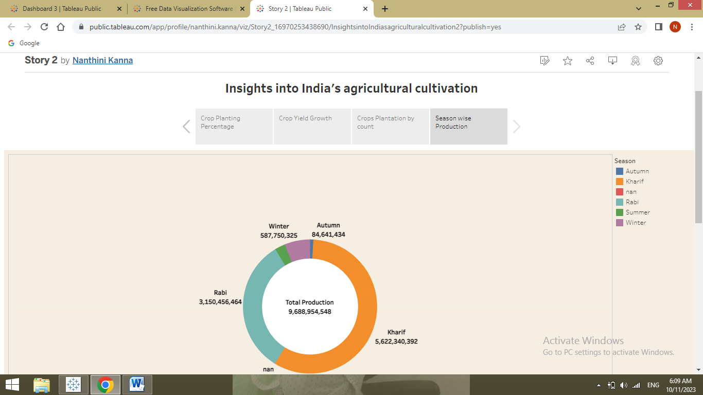

**7. ADVANTAGES & DISADVANTAGES**

**7.1 Advantages**

* Agriculture provides employment opportunities to rural agricultural and non-agricultural labourers.
* It plays a significant role in international trade and import and export activities.
* Agriculture supplies raw materials to various agro-based industries like sugar, jute, cotton textile industries.
* Food processing industries are similarly dependent on agriculture. Therefore the development of these industries entirely is dependent on agriculture.
* There is overall increase in yield of crops mainly due to maintaining physical- chemical properties of soil.

**7.2 Disadvantages**

* Inadequate and uneven distribution of rain fall.
* General, the rainfall is low and highly variable which results in uncertain crop yields.
* Besides its uncertainty, the distribution of rainfall during the crop period is uneven, receiving high amount of rain.

**8. APPLICATIONS**

* The history of agriculture in India dates back to the Neolithic period.
* India ranks second worldwide in farm outputs.
* As per the Indian economic survey 2020 -21, agriculture employed more than 50% of the Indian workforce and contributed 20.2% to the country's GDP.
* Agriculture technology or Agri technology is also known as agritech.
* It is efficient in mapping, monitoring, and managing farming decisions precisely.
* Agriculture solutions come in various formats such as satellite imagery, sensors, agriculture machines, and software solutions.

**9. CONCULSION**

 The Indian economy is an agro-economy and depends highly on the agricultural sector. Despite just supporting the Indian Economy, the agricultural sector also supports the industrial sector and international trade in imports and exports.

**10. FUTURE SCOPE**

Agriculture sector have an enormous scope in India as of the future reference because agriculture sector is the largest sector with 49% of country's population works in Agriculture sector by occupation. India is also a developing country with about 16% of its GDP is contributed by this sector.